|  |
| --- |
| MY IMAGE |
|  |
|  |
|  |

**Documentation of E-Project**

|  |  |
| --- | --- |
| **MUHAMMAD HUZAIFA** | **Student**1175352 |
| **RAZI** | **Student1175490** |
| **SYED MUHAMMAD AHMED KHURSHID** | **Student1204060** |
| **HAFIZ MUHAMMAD WAQAS** | **Student1235313** |

**Submitted To :** [eProjects@algsm.com](mailto:eProjects@algsm.com)

**Project Instructor : MISS ANUSHEH NAWAZI**

**BATCH CODE : 1909B2**



Introduction

# MY IMAGE:

# Introduction:

# “MyImage” is a group of people who wants to develop an online site were the user can upload his or her photographs and can order them for printing.

# A customer can have a set of digital photographs in his desktop which he/she wants to print.

# He/she can provide the application the path to the folder where the photographs are stored and can choose the photos that he/she wants to print and choose the size of the prints.

# The application will calculate the price after downloading the price information from the database for the different print sizes and show it to the user.

# The user will enter his/her credit card/other payment option (or choose any other mode of payment) and shipping information if he/she wants to go ahead with the order.

# If the credit card information is found correct, the photos are uploaded to the server and a purchase order is created in the database.

# USER GUIDE

We have created Website a that allows user to shop for online photo printing with different size pictures. User can also provide his picture size and specifications for printing of his photos.

## Requirements:

### Hardware

* A minimum computer system: Pentium 166 or better
* 128 Megabytes of RAM or better
* Windows 2000 Server (or higher if possible)

### Software

* Windows 8 Minimum

# Main Page:

This is our main page. It consists of our products, navigation bar, search bar and footer.

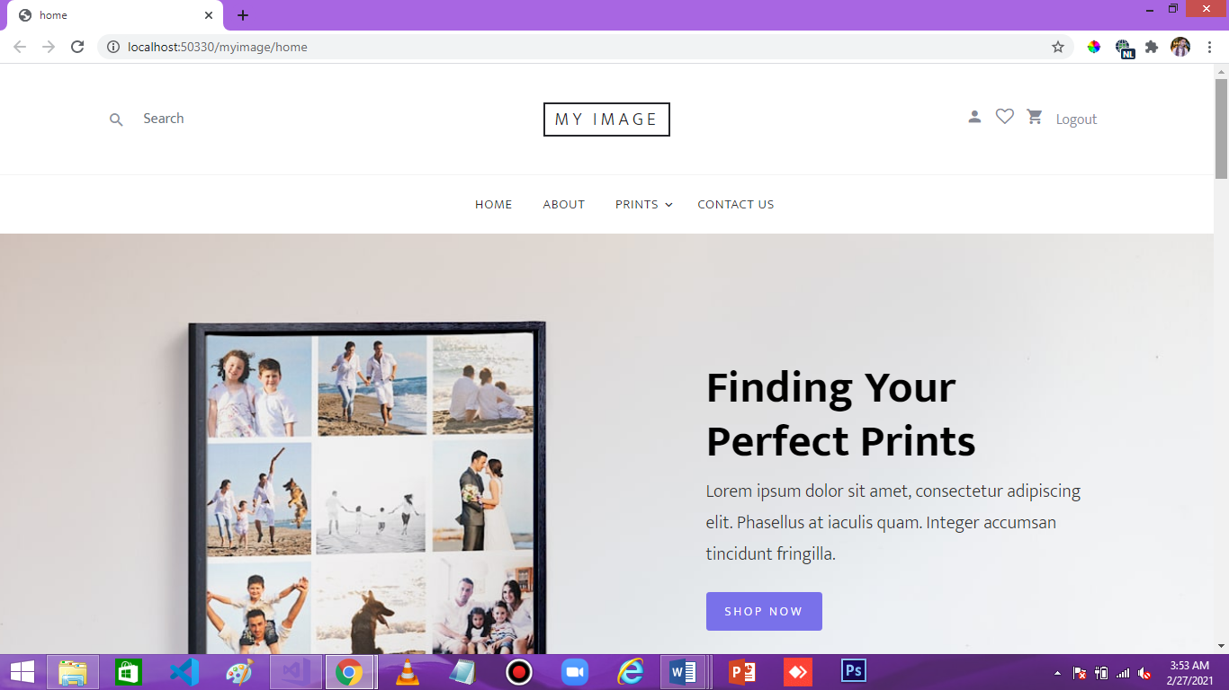

# Product Page:

This is our Product page. From here user can view our all products and can select photo style with Photo print size well. By clicking on a Picture..

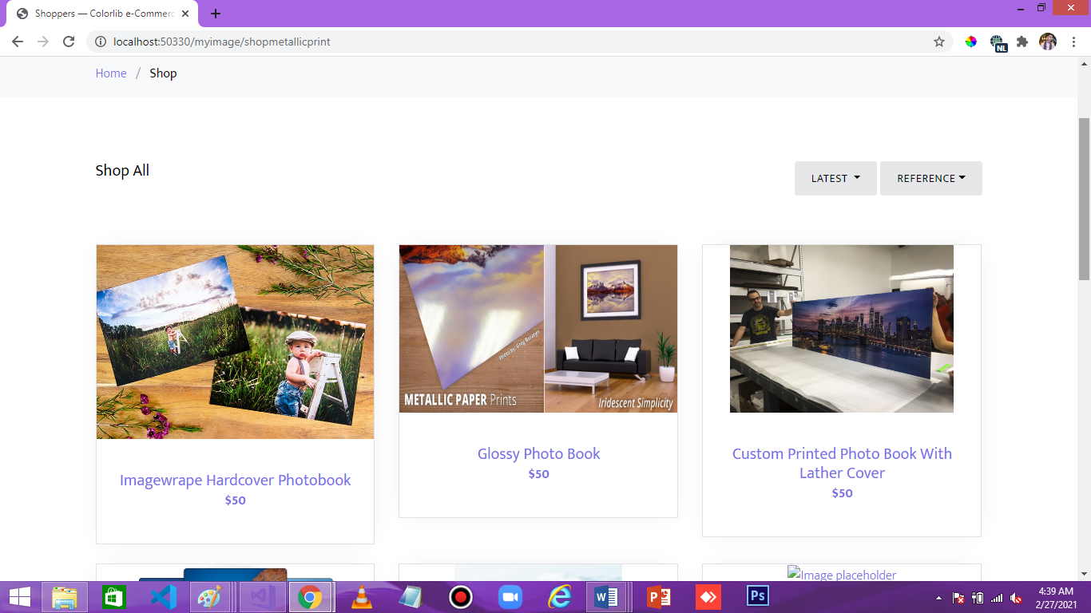

# Contact Us Page:

User can ask queries or give suggestions or feedback from this page.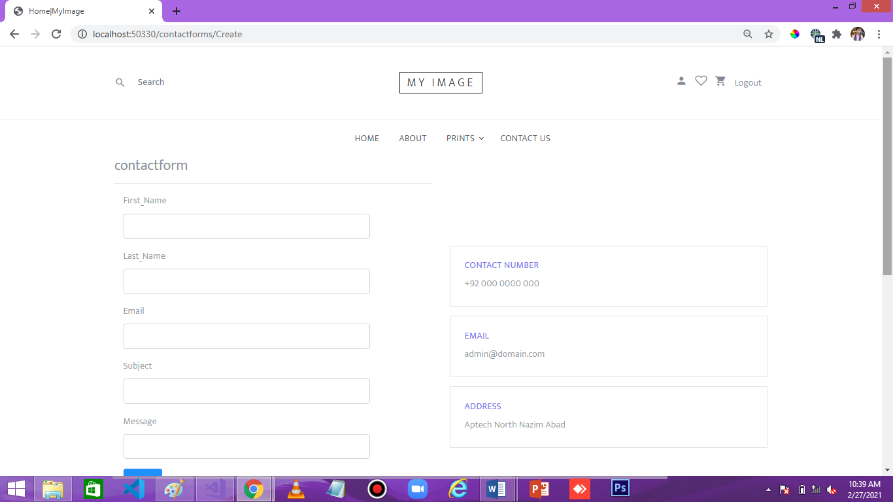

# Admin Dashboard:

From here details of the site can be updated by admin. He can also reply to feedbacks or answer queries asked by customers.

